A000-Eur-Germany-Nebra Disk-Bronze-Gold-1600 BCE

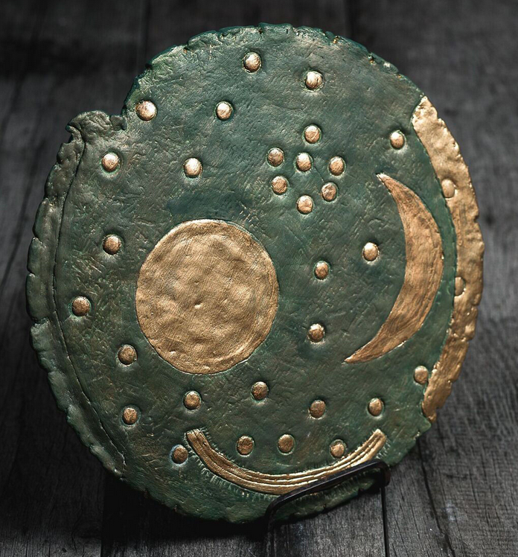 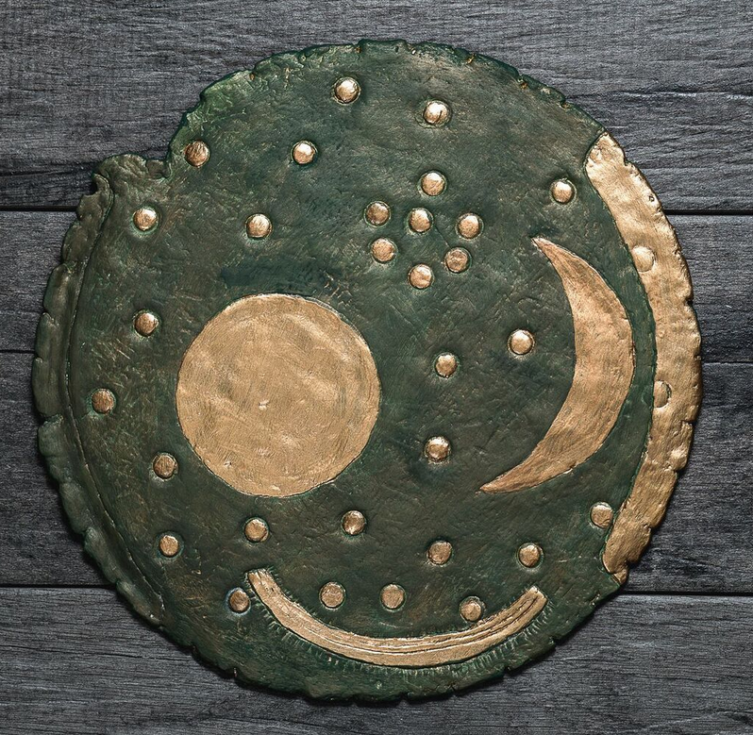

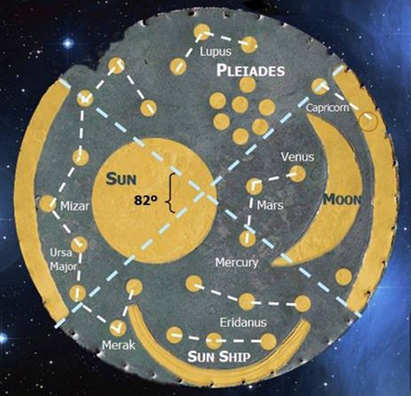

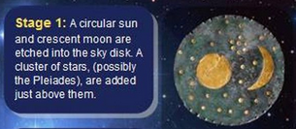 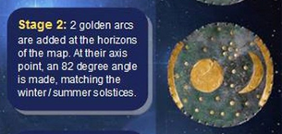 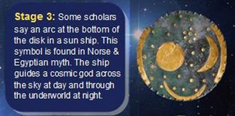 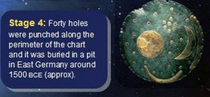

Figs. 1-7. Nebra Disk-Bronze-Gold-1600 BCE

The **Nebra sky disk** is a [bronze](https://en.wikipedia.org/wiki/Bronze) disk of around 30 centimeters (12 in) diameter and a weight of 2.2 kilograms (4.9 lb), with a blue-green [patina](https://en.wikipedia.org/wiki/Patina) and inlaid with gold symbols. These are interpreted generally as a sun or full moon, a lunar crescent, and stars (including a cluster interpreted as the [Pleiades](https://en.wikipedia.org/wiki/Pleiades)). Two golden arcs along the sides, marking the angle between the [solstices](https://en.wikipedia.org/wiki/Solstice), were added later. A final addition was another arc at the bottom surrounded with multiple strokes (of uncertain meaning, variously interpreted as a [Solar Barge](https://en.wikipedia.org/wiki/Solar_Deity#Solar_barge_and_sun_chariot) with numerous oars, as the [Milky Way](https://en.wikipedia.org/wiki/Milky_Way), or as a [rainbow](https://en.wikipedia.org/wiki/Rainbow)).

The disk is attributed to a site near [Nebra](https://en.wikipedia.org/wiki/Nebra_(Unstrut)), [Saxony-Anhalt](https://en.wikipedia.org/wiki/Saxony-Anhalt), in Germany, and [associatively](https://en.wikipedia.org/wiki/Archaeological_association) [dated](https://en.wikipedia.org/wiki/Chronological_dating) to c. 1600 BC. It has been associated with the [Bronze Age](https://en.wikipedia.org/wiki/European_Bronze_Age) [Unetice culture](https://en.wikipedia.org/wiki/Unetice_culture).

The disk is unlike any known artistic style from the period, and was initially suspected of being a [forgery](https://en.wikipedia.org/wiki/Forgery), but now is widely accepted as authentic.

The Nebra sky disk features the oldest concrete depiction of the [cosmos](https://en.wikipedia.org/wiki/Cosmos) worldwide. In June 2013 it was included in the [UNESCO](https://en.wikipedia.org/wiki/UNESCO) [Memory of the World Register](https://en.wikipedia.org/wiki/Memory_of_the_World_Programme) and termed "one of the most important archaeological finds of the twentieth century."[[1]](https://en.wikipedia.org/wiki/Nebra_sky_disk#cite_note-1)

The disk, two bronze swords, two hatchets, a chisel, and fragments of spiral bracelets were discovered in 1999 by Henry Westphal and Mario Renner while they were treasure-hunting with a metal detector. Archaeological artifacts are the property of the state in Saxony-Anhalt. The hunters were operating without a license and knew their activity constituted looting and was illegal. They damaged the disk with their spade and destroyed parts of the site. The next day, Westphal and Renner sold the entire hoard for 31,000 [DM](https://en.wikipedia.org/wiki/Deutsche_Mark) to a dealer in [Cologne](https://en.wikipedia.org/wiki/Cologne). The hoard changed hands within Germany over the next two years, being sold for up to a million DM. By 2001 knowledge of its existence became public. In February 2002 the state archaeologist Harald Meller acquired the disk in a police-led sting operation in [Basel](https://en.wikipedia.org/wiki/Basel) from a couple who had put it on the black market for 700,000 DM.[[2]](https://en.wikipedia.org/wiki/Nebra_sky_disk#cite_note-2) The original finders were eventually traced. In a plea bargain, they led police and archaeologists to the discovery site. Archaeologists opened a dig at the site and uncovered evidence that supports the looters' claims. There are traces of bronze artifacts in the ground, and the soil at the site matches soil samples found clinging to the artifacts. The disk and its accompanying finds are now held at the [State Museum of Prehistory](https://en.wikipedia.org/wiki/Halle_State_Museum_of_Prehistory) in [Halle](https://en.wikipedia.org/wiki/Halle_(Saale)).

The two looters received sentences of four months and ten months, respectively, from a [Naumburg](https://en.wikipedia.org/wiki/Naumburg" \o "Naumburg) court in September 2003. They appealed, but the appeals court raised their sentences to six and twelve months, respectively.

The discovery site is a [prehistoric enclosure](https://en.wikipedia.org/w/index.php?title=Prehistoric_enclosure&action=edit&redlink=1) encircling the top of a 252 metres (827 ft) elevation in the [Ziegelroda Forest](https://en.wikipedia.org/w/index.php?title=Ziegelroda_Forest&action=edit&redlink=1" \o "Ziegelroda Forest (page does not exist)), known as *Mittelberg*("central hill"), some 60 km west of [Leipzig](https://en.wikipedia.org/wiki/Leipzig). The surrounding area is known to have been settled in the [Neolithic](https://en.wikipedia.org/wiki/Neolithic) era, and Ziegelroda Forest contains approximately 1,000 [barrows](https://en.wikipedia.org/wiki/Tumulus).

The enclosure is oriented in such a way that the sun seems to set every [solstice](https://en.wikipedia.org/wiki/Solstice) behind the [Brocken](https://en.wikipedia.org/wiki/Brocken), the highest peak of the [Harz](https://en.wikipedia.org/wiki/Harz) mountains, some 80 km to the north-west. The treasure-hunters claimed the artifacts were discovered within a pit inside the bank-and-ditch enclosure.

## Dating[[edit](https://en.wikipedia.org/w/index.php?title=Nebra_sky_disk&action=edit&section=2" \o "Edit section: Dating)]

[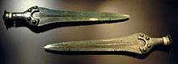](https://en.wikipedia.org/wiki/File:Nebra_Schwerter.jpg)

The [swords](https://en.wikipedia.org/wiki/Bronze_Age_sword) found with the disk

[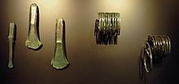](https://en.wikipedia.org/wiki/File:Nebra_Hort.jpg)

Other associated finds: chisel, axeheads, bracelets

The precise [dating](https://en.wikipedia.org/wiki/Chronological_dating) of the Nebra sky disk depended upon the dating of a number of Bronze Age weapons, which were offered for sale with the disk and said to be from the same site. These axes and swords can be dated typologically to the mid 2nd millennium BC. [Radiocarbon dating](https://en.wikipedia.org/wiki/Radiocarbon_dating) of a birchbark particle found on one of the swords to between 1600 and 1560 BC confirmed this estimate. This corresponds to the date of burial, at which time the disk had likely been in existence for several generations.

## Origin of the metals[[edit](https://en.wikipedia.org/w/index.php?title=Nebra_sky_disk&action=edit&section=3" \o "Edit section: Origin of the metals)]

According to an initial analysis of trace elements by [x-ray fluorescence](https://en.wikipedia.org/wiki/X-ray_fluorescence) by E. Pernicka, then at the [University of Freiberg](https://en.wikipedia.org/wiki/Freiberg_University_of_Mining_and_Technology), the copper originated at [Bischofshofen](https://en.wikipedia.org/wiki/Bischofshofen" \o "Bischofshofen) in Austria, while the [gold](https://en.wikipedia.org/wiki/Gold) was thought to be from the [Carpathian Mountains](https://en.wikipedia.org/wiki/Carpathian_Mountains).[[3]](https://en.wikipedia.org/wiki/Nebra_sky_disk#cite_note-3) A more recent analysis found that the gold used in the first phase was from the [river Carnon](https://en.wikipedia.org/wiki/River_Carnon) in [Cornwall](https://en.wikipedia.org/wiki/Cornwall), United Kingdom.[[4]](https://en.wikipedia.org/wiki/Nebra_sky_disk#cite_note-Ehser-4) The tin content of the bronze was also from Cornwall.[[5]](https://en.wikipedia.org/wiki/Nebra_sky_disk#cite_note-5)

## History[[edit](https://en.wikipedia.org/w/index.php?title=Nebra_sky_disk&action=edit&section=4" \o "Edit section: History)]

The disk as preserved was developed in four stages (Meller 2004):

1. Initially the disk had thirty-two small round gold circles, a large circular plate, and a large crescent-shaped plate attached. The circular plate is interpreted as either the [Sun](https://en.wikipedia.org/wiki/Sun) or the [full Moon](https://en.wikipedia.org/wiki/Full_Moon), the crescent shape as the [crescent Moon](https://en.wikipedia.org/wiki/Lunar_phase) (or either the Sun or the Moon undergoing [eclipse](https://en.wikipedia.org/wiki/Eclipse)), and the dots as [stars](https://en.wikipedia.org/wiki/Star), with the cluster of seven dots likely representing the [Pleiades](https://en.wikipedia.org/wiki/Pleiades).
2. At some later date, two arcs (constructed from gold of a different origin, as shown by its chemical impurities) were added at opposite edges of the disk. To make space for these arcs, one small circle was moved from the left side toward the center of the disk and two of the circles on the right were covered over, so that thirty remain visible. The two arcs span an angle of 82°, correctly indicating the angle between the positions of sunset at summer and winter [solstice](https://en.wikipedia.org/wiki/Solstice) at the latitude of the Mittelberg (51°N)[[6]](https://en.wikipedia.org/wiki/Nebra_sky_disk#cite_note-McIntosh-6). Given that the arcs relate to solar phenomena, it is likely the circular plate represents the Sun not the Moon.
3. The final addition was another arc at the bottom, the "[sun boat](https://en.wikipedia.org/wiki/Solar_barge)", again made of gold from a different origin.
4. By the time the disk was buried it also had thirty-nine or forty holes punched out around its perimeter, each approximately 3 mm in diameter.

* [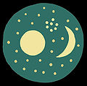](https://en.wikipedia.org/wiki/File:Nebra-1.jpg)

1) On the left the [full moon](https://en.wikipedia.org/wiki/Full_moon), on the right the [waxing moon](https://en.wikipedia.org/wiki/Waxing_moon), and between and above, the [Pleiades](https://en.wikipedia.org/wiki/Pleiades)

* [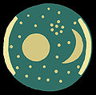](https://en.wikipedia.org/wiki/File:Nebra-2.jpg)

2) Arcs were added on the horizon for the zones of the [rising](https://en.wikipedia.org/wiki/Sunrise) and [setting](https://en.wikipedia.org/wiki/Sunset" \o "Sunset)sun; individual stars were shifted and/or covered

* [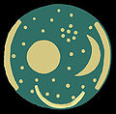](https://en.wikipedia.org/wiki/File:Nebra-3.jpg)

3) Addition of the "[sun boat](https://en.wikipedia.org/wiki/Solar_barge)"

* [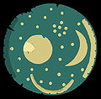](https://en.wikipedia.org/wiki/File:Nebra-4.jpg)

4) Diagram of the disk in its current condition (a star and a part of the sun—or full moon—have been restored)

## Significance[[edit](https://en.wikipedia.org/w/index.php?title=Nebra_sky_disk&action=edit&section=5" \o "Edit section: Significance)]

The disk may be an [astronomical](https://en.wikipedia.org/wiki/Archaeoastronomy) instrument as well as an item of [religious](https://en.wikipedia.org/wiki/Prehistoric_religion) significance. The blue-green patina of the bronze may have been an intentional part of the original artifact.[[7]](https://en.wikipedia.org/wiki/Nebra_sky_disk#cite_note-meller2002-7)

The find is regarded as reconfirming that the astronomical knowledge and abilities of the people of the [European Bronze Age](https://en.wikipedia.org/wiki/European_Bronze_Age) included close observation of the yearly course of the [Sun](https://en.wikipedia.org/wiki/Sun), and the angle between its rising and setting points at summer and winter [solstice](https://en.wikipedia.org/wiki/Solstice). While much older [earthworks](https://en.wikipedia.org/wiki/Earthworks_(archaeology)) and [megalithic](https://en.wikipedia.org/wiki/Megalithic) [astronomical complexes](https://en.wikipedia.org/wiki/Astronomical_complex) such as the [Goseck circle](https://en.wikipedia.org/wiki/Goseck_circle" \o "Goseck circle) and [Stonehenge](https://en.wikipedia.org/wiki/Stonehenge) had already been used to mark the solstices, the disk is the oldest known "portable instrument" to allow such measurements. Pásztor, however, sees no evidence that the disk was a practical device for solar measurements.[[8]](https://en.wikipedia.org/wiki/Nebra_sky_disk#cite_note-8)

[Euan MacKie](https://en.wikipedia.org/wiki/Euan_MacKie) suggests that the Nebra disk may be linked to the solar calendar reconstructed by [Alexander Thom](https://en.wikipedia.org/wiki/Alexander_Thom) from his analysis of standing stone alignments in Britain.[[9]](https://en.wikipedia.org/wiki/Nebra_sky_disk#cite_note-MacKie2006-9)

## Authenticity[[edit](https://en.wikipedia.org/w/index.php?title=Nebra_sky_disk&action=edit&section=6" \o "Edit section: Authenticity)]

There were initial suspicions that the disk might be an [archaeological forgery](https://en.wikipedia.org/wiki/Archaeological_forgery). Peter Schauer of the University of Regensburg, Germany, argued in 2005 that the Nebra disk was a fake and that he could prove that the patina of the disk could be created with urine, hydrochloric acid and a blow torch within a short amount of time. He had to admit in court that he had never held the disk in his own hands, unlike eighteen scientists who had examined the disk.[[10]](https://en.wikipedia.org/wiki/Nebra_sky_disk#cite_note-10)

Richard Harrison, professor of European prehistory at the [University of Bristol](https://en.wikipedia.org/wiki/University_of_Bristol) and an expert on the [Beaker people](https://en.wikipedia.org/wiki/Beaker_people), allowed his initial reaction to be quoted in a [BBC](https://en.wikipedia.org/wiki/BBC) documentary:[[11]](https://en.wikipedia.org/wiki/Nebra_sky_disk#cite_note-BBC2008-11)

"When I first heard about the Nebra Disc I thought it was a joke, indeed I thought it was a forgery. Because it’s such an extraordinary piece that it wouldn’t surprise any of us that a clever forger had cooked this up in a backroom and sold it for a lot of money."

Although Harrison had not seen the skydisk when he was interviewed, his skepticism was reasonable at that point, but the disk is widely accepted now as authentic and is dated to roughly 1600 BC on grounds of typological classification of the associated finds. As the item was not excavated using archaeological methods, even its claimed provenance may be made up, hence authenticating it has depended on microphotography of the corrosion crystals,[[11]](https://en.wikipedia.org/wiki/Nebra_sky_disk" \l "cite_note-BBC2008-11) which produced images that could not be reproduced by a faker.

[](https://en.wikipedia.org/wiki/File:SkyDiscVisitorsCentre.JPG)

The Sky Disc Visitor Center near Nebra

Harald Meller, lecturing to the Society of Antiquaries of Scotland in April 2008, gave a list of facts supporting the authenticity of the disc, and for its having been found at the site on the Mittelberg. The most persuasive of the latter was the discovery by the archaeologists — in the pit in which the looters said they had found the metalwork — of a fragment of gold leaf exactly fitting the gap present in the gold leaf covering of the 'sun' symbol when it was originally recovered.

References[[edit](https://en.wikipedia.org/w/index.php?title=Nebra_sky_disk&action=edit&section=10" \o "Edit section: References)]

* 1. [**Jump up^**](https://en.wikipedia.org/wiki/Nebra_sky_disk#cite_ref-1) [*"Nebra Sky Disc"*](http://www.unesco.org/new/en/communication-and-information/flagship-project-activities/memory-of-the-world/register/full-list-of-registered-heritage/registered-heritage-page-6/nebra-sky-disc/)*. Unesco memory of the World. 2013.*
  2. [**Jump up^**](https://en.wikipedia.org/wiki/Nebra_sky_disk#cite_ref-2) *Meller, H. (January 2004). "Star search". National Geographic: 76–8.*
  3. [**Jump up^**](https://en.wikipedia.org/wiki/Nebra_sky_disk#cite_ref-3) *Pernicka, E. & Wunderlich, C-H. "Naturwissenschaftliche Untersuchungen an den Funden von Nebra". Archäologie in Sachsen-Anhalt.****1/02****: 24–29.*
  4. [**Jump up^**](https://en.wikipedia.org/wiki/Nebra_sky_disk#cite_ref-Ehser_4-0) *Ehser, Anja; Borg, Gregor; Pernicka, Ernst (2011).*[*"Provenance of the gold of the Early Bronze Age Nebra Sky Disk, central Germany: geochemical characterization of natural gold from Cornwall"*](http://eurjmin.geoscienceworld.org/content/23/6/895.short)*. European Journal of Mineralogy.****23****(6): 895–910.*[*Bibcode*](https://en.wikipedia.org/wiki/Bibcode)*:[2011EJMin..23..895E](http://adsabs.harvard.edu/abs/2011EJMin..23..895E).*[*doi*](https://en.wikipedia.org/wiki/Digital_object_identifier)*:*[*10.1127/0935-1221/2011/0023-2140*](https://doi.org/10.1127%2F0935-1221%2F2011%2F0023-2140)*. Retrieved 12 November 2013.*
  5. [**Jump up^**](https://en.wikipedia.org/wiki/Nebra_sky_disk#cite_ref-5) *Haustein, M. (2010). "Tin isotopy: a new method for solving old questions". Archaeometry.****52****: 816–832.*[*doi*](https://en.wikipedia.org/wiki/Digital_object_identifier)*:*[*10.1111/j.1475-4754.2010.00515.x*](https://doi.org/10.1111%2Fj.1475-4754.2010.00515.x)*.*
  6. [**Jump up^**](https://en.wikipedia.org/wiki/Nebra_sky_disk#cite_ref-McIntosh_6-0) *McIntosh, Jane (2010). Lost Treasures; Civilization's Great Riches Rediscovered. London: Carlton Books. p. 16.*[*ISBN*](https://en.wikipedia.org/wiki/International_Standard_Book_Number)[*9781847322999*](https://en.wikipedia.org/wiki/Special:BookSources/9781847322999)*.*
  7. [**Jump up^**](https://en.wikipedia.org/wiki/Nebra_sky_disk#cite_ref-meller2002_7-0) *Meller, H (2002). "Die Himmelsscheibe von Nebra – ein frühbronzezeitlicher Fund von außergewohnlicher Bedeutung". Archäeologie in Sachsen-Anhalt.****1/02****: 7–30.*
  8. [**Jump up^**](https://en.wikipedia.org/wiki/Nebra_sky_disk#cite_ref-8) *Pásztor, Emilia (2015), "Nebra Disk", in Ruggles, Clive L. N., Handbook of Archaeoastronomy and Ethnoastronomy, New York: Springer Science+Business Media, pp. 1349–1356,*[*doi*](https://en.wikipedia.org/wiki/Digital_object_identifier)*:*[*10.1007/978-1-4614-6141-8\_128*](https://doi.org/10.1007%2F978-1-4614-6141-8_128)*,*[*ISBN*](https://en.wikipedia.org/wiki/International_Standard_Book_Number)[*978-1-4614-6140-1*](https://en.wikipedia.org/wiki/Special:BookSources/978-1-4614-6140-1)
  9. [**Jump up^**](https://en.wikipedia.org/wiki/Nebra_sky_disk#cite_ref-MacKie2006_9-0) *MacKie, E (2006). "New evidence for a professional priesthood in the European Early Bronze Age?". In Todd W. Bostwick; Bryan Bates. Viewing the Sky Through Past and Present Cultures: Selected Papers from the Oxford VII International Conference on Archaeoastronomy.*[*Pueblo Grande Museum*](https://en.wikipedia.org/wiki/Pueblo_Grande_Ruin_and_Irrigation_Sites)*Anthropological Papers.****15****. City of Phoenix Parks and Recreation Department. pp. 343–362.*[*ISBN*](https://en.wikipedia.org/wiki/International_Standard_Book_Number)[*1-882572-38-6*](https://en.wikipedia.org/wiki/Special:BookSources/1-882572-38-6)*.*
  10. [**Jump up^**](https://en.wikipedia.org/wiki/Nebra_sky_disk#cite_ref-10) [*"Himmelsscheibe von Nebra - Eine Komödie der Irrungen"*](http://www.faz.net/s/RubCD175863466D41BB9A6A93D460B81174/Doc~E4115FE522E3C4CDD89890E5C3B4A9106~ATpl~Ecommon~Scontent.html)*(in German).*[*Frankfurter Allgemeine Zeitung*](https://en.wikipedia.org/wiki/Frankfurter_Allgemeine_Zeitung)*. March 17, 2005. Retrieved 2010-05-12.*
  11. ^ [Jump up to:***a***](https://en.wikipedia.org/wiki/Nebra_sky_disk#cite_ref-BBC2008_11-0) [***b***](https://en.wikipedia.org/wiki/Nebra_sky_disk#cite_ref-BBC2008_11-1) [*"BBC - Science & Nature - Horizon - Secrets of the Star Disc"*](http://www.bbc.co.uk/science/horizon/2004/stardisctrans.shtml)*. BBC. 2004. Retrieved 2008-03-25.*
  12. [**Jump up^**](https://en.wikipedia.org/wiki/Nebra_sky_disk#cite_ref-12) Himmelsscheibe von Nebra [*"Archived copy"*](https://web.archive.org/web/20110719051336/http:/www.kalkriese.de/Himmelsscheibe_von_Nebra.html)*. Archived from*[*the original*](http://www.kalkriese.de/Himmelsscheibe_von_Nebra.html)*on 2011-07-19. Retrieved 2009-11-16.*

Further reading[[edit](https://en.wikipedia.org/w/index.php?title=Nebra_sky_disk&action=edit&section=11" \o "Edit section: Further reading)]

* Ute Kaufholz: *Sonne, Mond und Sterne. Das Geheimnis der Himmelsscheibe.* Anderbeck, Anderbeck 2004, [ISBN](https://en.wikipedia.org/wiki/International_Standard_Book_Number) [3-937751-05-X](https://en.wikipedia.org/wiki/Special:BookSources/3-937751-05-X)
* Landesamt für Archäologie Sachsen-Anhalt (Hrsg.): *Archäologie in Sachsen-Anhalt.* Dt. Verl. d. Wissenschaften, Halle 1.2002, S.7–31. [ISSN](https://en.wikipedia.org/wiki/International_Standard_Serial_Number) [0072-940X](https://www.worldcat.org/search?fq=x0:jrnl&q=n2:0072-940X)
* Frank Hagen von Liegnitz: *Die Sonnenfrau* Weihnachtsgabe der WeserStrom Genossenschaft, Bremen 2002.
* Harald Meller (Hrsg.): *Der geschmiedete Himmel. Die weite Welt im Herzen Europas vor 3600 Jahren.* Ausstellungskatalog. Theiss-Verlag, Stuttgart 2004, [ISBN](https://en.wikipedia.org/wiki/International_Standard_Book_Number) [3-8062-1907-9](https://en.wikipedia.org/wiki/Special:BookSources/3-8062-1907-9)
* Katja Näther, Sven Näther: *Akte Nebra – Keine Sonne auf der Himmelsscheibe?* Naether, Wilhelmshorst 2004, [ISBN](https://en.wikipedia.org/wiki/International_Standard_Book_Number) [3-934858-02-3](https://en.wikipedia.org/wiki/Special:BookSources/3-934858-02-3)
* [*National Geographic*](https://en.wikipedia.org/wiki/National_Geographic_(magazine))*Deutschland.* Gruner + Jahr, Hamburg 2004,1, S.38–61, [ISBN](https://en.wikipedia.org/wiki/International_Standard_Book_Number) [3-936559-85-6](https://en.wikipedia.org/wiki/Special:BookSources/3-936559-85-6)
* Uwe Reichert: *Der geschmiedete Himmel.* in: *[Spektrum der Wissenschaft](https://en.wikipedia.org/wiki/Spektrum_der_Wissenschaft" \o "Spektrum der Wissenschaft).* Heidelberg 2004,11, S.52–59. [ISSN](https://en.wikipedia.org/wiki/International_Standard_Serial_Number) [0170-2971](https://www.worldcat.org/search?fq=x0:jrnl&q=n2:0170-2971)
* Ch. Sommerfeld : ...Sterne mal Sterne durch Sonne ist Mond - Bemerkungen über die Nebra-Scheibe, *Praehistorische Zeitschrift*, 87(1) 2012, S. 110-131. [ISSN](https://en.wikipedia.org/wiki/International_Standard_Serial_Number) [1613-0804](https://www.worldcat.org/search?fq=x0:jrnl&q=n2:1613-0804)
* Der Sternenkult der Ur-Germanen. Titelbericht im Nachrichtenmagazin DER SPIEGEL vom 25.11.2002.

The Nebra Disk dates to 1600 BCE, the bronze disc has a diameter of 32cm and weighs around 2 kg. It is patinated blue-green and embossed with gold leaf symbols which appear to represent a crescent moon, the sun (or perhaps a full moon), stars, a curved gold band, interpreted as a sun boat, and a further gold band on the edge of the disc which probably represent one of the horizons (another gold band on the opposite side is missing).   
  
The Nebra disk was discovered in 1999 by treasure hunters using a metal detector at a prehistoric enclosure encircling Mittelberg hill, near the town of Nebra in the Ziegelroda Forest, 180km south-west of Berlin, Germany. Unfortunately the treasure hunters caused considerable damage to the disc during its crude removal from the ground, which included splintering its outer rim, losing one of the stars, and chipping a large piece off the gold disc.   
  
The looters subsequently attempted to sell the disc, along with two swords, two axes, a chisel, and fragments of armlets, to local archaeologists. But they discovered that by law the objects belonged to the state of Sachsen-Anhalt, where they were unearthed, so they could not be sold legally. In February, 2003, they tried selling the disc to an antiquities collector in Switzerland for $400,000. However, the 'collector' was actually working for the Swiss police as part of a 'sting' operation to trap the group, which played out in the basement bar of the Hilton hotel in Basle. The group were subsequently arrested and the disc was recovered. It is now the property of the state of Sachsen-Anhalt.   
  
As mentioned above, the disc illustrates the crescent moon, a sun or full moon, three arcs, and 23 stars dotted around, apparently at random. There is a further cluster of seven stars, identified as the Pleiades constellation. X-Rays have revealed two more stars underneath the gold of the right arc, suggesting that the two arcs were added later than the other features. The blue-green background of the night sky was once colored a deep violet-blue, apparently by applying rotten eggs, causing a chemical reaction on the bronze surface. Running along the edge of the disc is a ring of holes punched through the metal, probably for attaching the disc to something, perhaps a piece of heavy cloth.   
  
**What is the Nebra Sky Disc?**   
Many researchers believe it is the oldest known representation of the cosmos yet found, perhaps a kind of advanced astronomical clock to determine planting and harvest times. Across northern Europe, ancient monuments were aligned to mark the summer and winter solstices, such as Stonehenge in Wiltshire, England, and Newgrange in Ireland.   
  
As Bronze Age people were an agricultural society, a method for predicting the correct times for planting and harvesting crops was obviously vital. One way of doing this was to identify the position of the sun at sunrise and sunset. Intrigued by the possibility of the Nebra disk as an astronomical device,

Wolfhard Schlosser, of the University of Bochum, measured the angle between the pair of arcs on either side of the disc, and found that it was eighty two degrees.   
  
At Mittelberg hill, between the high mid-summer sunset and the low mid-winter sunset, the sun appears to travel around eighty two degrees along the horizon. This angle would vary from place to place, further north, for example, it would be ninety degrees, and to the south, seventy. But in a restricted belt of central Europe, the suns passage across the sky measures precisely eighty two degrees. Schlosser concluded that the pair of arcs along the circumference of the Nebra disk did indeed depict the sun solstices accurately for its location. This would suggest that the Bronze Age agricultural societies of Central Europe made sophisticated celestial measurements far earlier than has been suspected.   
  
**Ancient Astronomy**   
Some researchers have pointed to the presence of the Pleiades star cluster on the disc as further evidence of Bronze Age astronomical knowledge. Although nowadays there are only six stars in the Pleiades visible to the naked eye, in the Bronze Age one of the group stars may have been much brighter, thus accounting not only for the depiction of seven stars on the disc, but also for the ancient Greek name for the cluster - the 'Seven Sisters'.   
  
The Pleiades was an important constellation for many ancient civilizations, including those of Mesopotamia and Greece. The constellation would have appeared in their skies in the autumn, showing that it was time to start bringing in the harvest, and disappeared in the spring, indicating the time for planting crops. This evidence for the importance of the disc in connection with prehistoric agriculture may mean that the (third) golden arc underneath the crescent moon and golden disc in fact represents a sickle.   
  
Others have suggested that the disc actually represents the day-time sky and that the unexplained arc depicts a rainbow. But the majority of researchers believe this third arc to be a 'sun ship'. There are depictions of a disk in a ship from Bronze Age Scandinavia, and a Danish artefact dating to the 15th / 14th century BCE, the 'Trundholm Sun Chariot', depicts a horse drawing the sun in a chariot. But the main source of the symbol and the ancient belief that a ship carried the sun across the night sky from the Western to Eastern horizon is Egypt. Their belief was that Rah, the sun god and their most potent deity, journeyed through the night sky on a ship in order that in the morning, at sunrise, he could be reborn.   
  
If the golden arc at the bottom of the Nebra disk does in fact represent a sun ship travelling across the night sky, then it will be the first evidence of such a belief in central Europe.   
  
**Germany's Stonehenge - The Goseck Circle**   
There is further proof of prehistoric celestial knowledge in the area, a mere 25km distant from where the Nebra disk was discovered. Lying in a wheat field near the town of Goseck, and first identified from aerial photographs, is the remains of what is thought to be Europe's oldest observatory. 'Germany's Stonehenge' as it has become known, consists of a huge a huge circle, 75m in diameter, and was built by the earliest farming communities in the area around 4,900 BCE. Originally the site consisted of four concentric circles, a mound, a ditch and two wooden palisades about the height of a person.   
  
Within the palisades were three sets of gates, facing southeast, southwest and north, respectively. The two southern gates marked the sunrise and sunset of both the summer and winter solstice. At the winter solstice, watchers at the center of the circles would have witnessed the sun rise and set through the south east and south west gates. It is surely safe to assume that if these southern gates marked the sunrise and sunset at the winter and summer solstice, then the inhabitants of Goseck were able to accurately determine the course of the sun in its journey across the sky. In fact the angle between the two solstice gates in the Goseck circle corresponds with the angle between the gilded arcs on the rim of the Nebra sky-disk.   
  
Although the Nebra disk was created 2,400 years later than the Goseck site, Professor Wolfhard Schlosser believes there may be some connection between the two in the astronomical knowledge they both display. Schlosser has even suggested that the details on the disc were based on previous astrological observations, possibly made at the primitive observatory at Goseck.